**Ambavaram Tirumala Kondareddy(192210642)**

**6. Use Figma to simulate a handoff scenario in a mobile network and visualize the process.**

**Aim: -To simulate a handoff scenario in a mobile network and visualize the process using Figma.**

**Procedure:**

**1. Open Figma**

**2. Create a new file**

**3. Select the Frames**

**4. Fill in the content that is required for presentation**

**5. Design Visual Elements**

**6. Make it Interactive**

**7. Add Annotations and Explanations**

**8. Incorporate Multimedia**

**9. Storyboard Animation**

**10. Review and edit the Prototype**

**11. Save and Share**

**Design:**

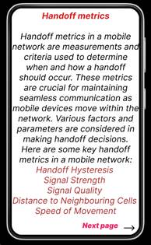

**Prototype:**

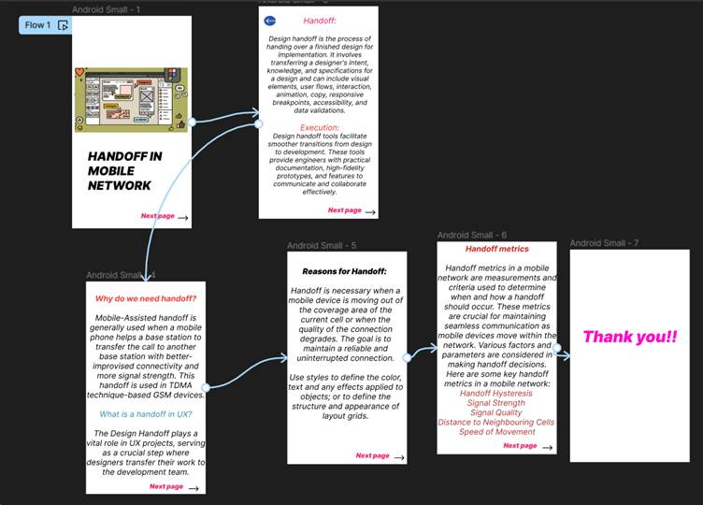

**Result:**

Hence the simulated a handoff scenario in a mobile network and visualized the process using Figma.